Heptagonal Pyramid
# Source: AI Source: Provided by: [Data Path: Persons Table -> ID Column: 1, Name_En Column: Motasem Essam] -> From: [ChatGPT] on [7/25/2026]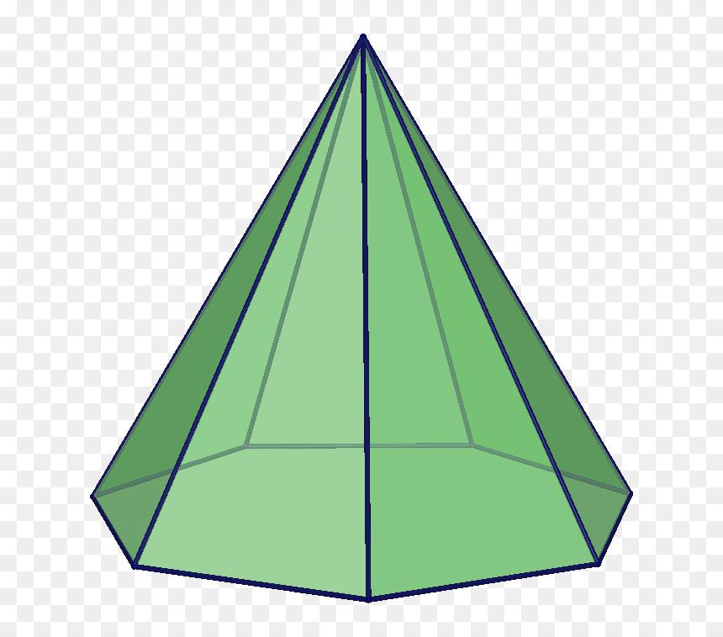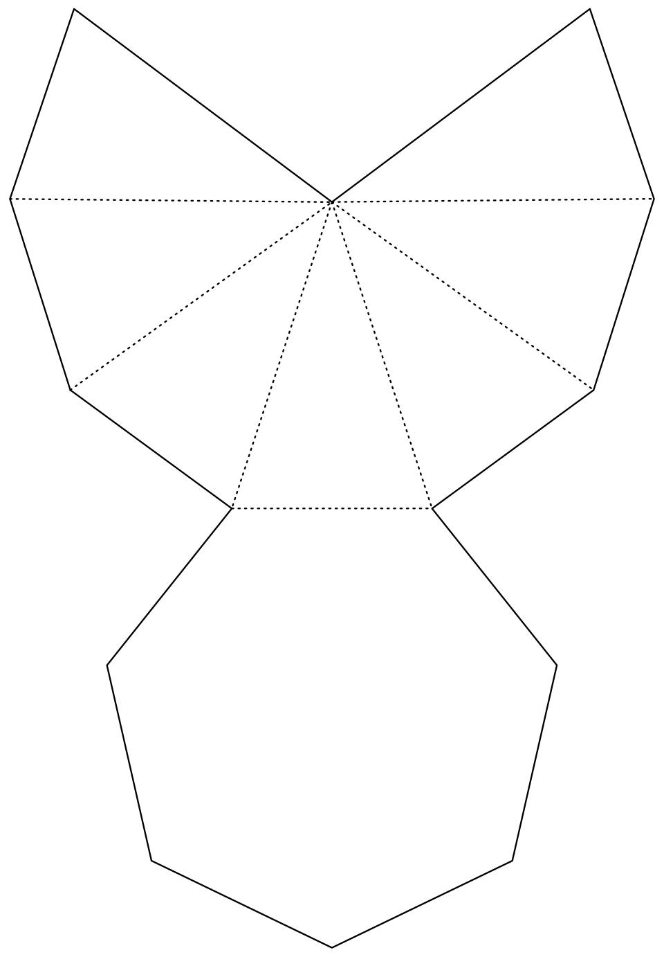

Definition
# Source: AI Source: Provided by: [Data Path: Persons Table -> ID Column: 1, Name_En Column: Motasem Essam] -> From: [ChatGPT] on [7/25/2026]
A Heptagonal Pyramid is a three-dimensional geometric solid with a heptagonal base (a polygon with seven sides) and seven triangular lateral faces that meet at a single common point called the apex.
The base may be a regular or irregular heptagon. The lateral faces may be isosceles or scalene triangles, depending on the arrangement of the apex and the base vertices.

Simple Definition
# Source: AI Source: Provided by: [Data Path: Persons Table -> ID Column: 1, Name_En Column: Motasem Essam] -> From: [ChatGPT] on [7/25/2026]
A Heptagonal Pyramid is a solid with:
- One seven-sided polygon as its base.
- Seven triangular faces surrounding the base.
- One apex where all seven triangular faces meet.

Classification Tree
# Source: AI Source: Provided by: [Data Path: Persons Table -> ID Column: 1, Name_En Column: Motasem Essam] -> From: [ChatGPT] on [7/25/2026]
Solid Geometry
└── Types of Solids
└── Pyramids
└── Types of Pyramids
└── Heptagonal Pyramid
├── Regular Heptagonal Pyramid
└── Irregular Heptagonal Pyramid
According to the position of the apex:
- Right Heptagonal Pyramid
- Oblique Heptagonal Pyramid

Key Characteristics
# Source: AI Source: Provided by: [Data Path: Persons Table -> ID Column: 1, Name_En Column: Motasem Essam] -> From: [ChatGPT] on [7/25/2026]
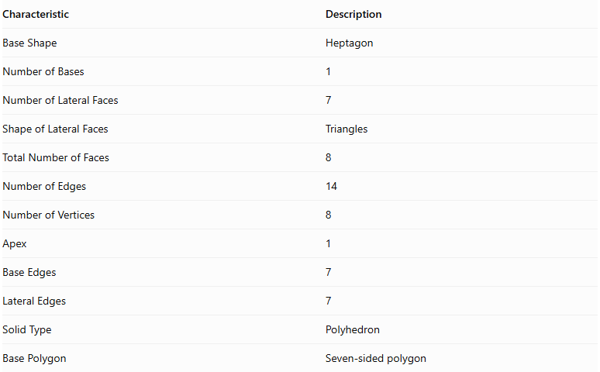
Characteristic | Description
Base Shape | Heptagon
Number of Bases | 1
Number of Lateral Faces | 7
Shape of Lateral Faces | Triangles
Total Number of Faces | 8
Number of Edges | 14
Number of Vertices | 8
Apex | 1
Base Edges | 7
Lateral Edges | 7
Solid Type | Polyhedron
Base Polygon | Seven-sided polygon

Regular Heptagonal Pyramid
# Source: AI Source: Provided by: [Data Path: Persons Table -> ID Column: 1, Name_En Column: Motasem Essam] -> From: [ChatGPT] on [7/25/2026]
A Regular Heptagonal Pyramid has a regular heptagon as its base, and its apex is positioned directly above the center of the base in a right pyramid.
Its seven lateral faces are congruent isosceles triangles.

Geometric Representation
# Source: AI Source: Provided by: [Data Path: Persons Table -> ID Column: 1, Name_En Column: Motasem Essam] -> From: [ChatGPT] on [7/25/2026]
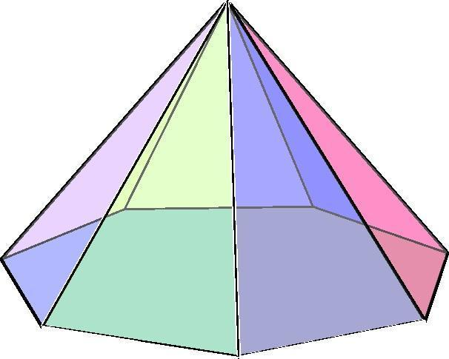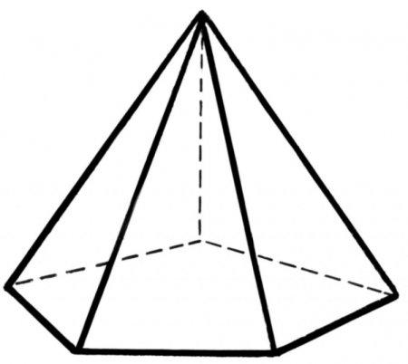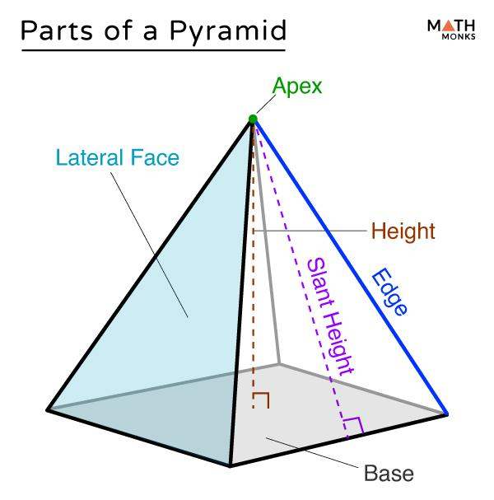

Main Components
# Source: AI Source: Provided by: [Data Path: Persons Table -> ID Column: 1, Name_En Column: Motasem Essam] -> From: [ChatGPT] on [7/25/2026]
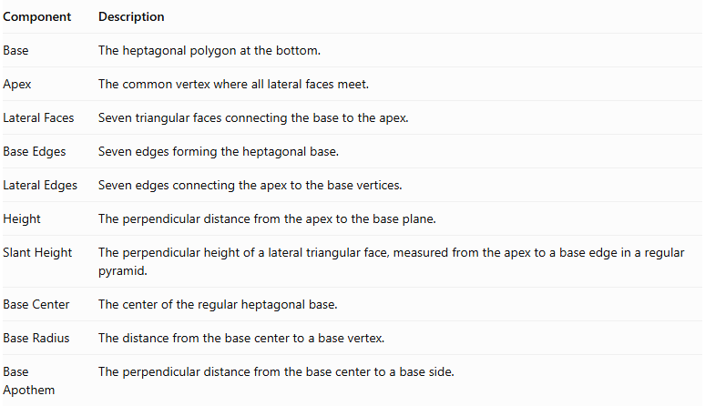
Component | Description
Base | The heptagonal polygon at the bottom.
Apex | The common vertex where all lateral faces meet.
Lateral Faces | Seven triangular faces connecting the base to the apex.
Base Edges | Seven edges forming the heptagonal base.
Lateral Edges | Seven edges connecting the apex to the base vertices.
Height | The perpendicular distance from the apex to the base plane.
Slant Height | The perpendicular height of a lateral triangular face, measured from the apex to a base edge in a regular pyramid.
Base Center | The center of the regular heptagonal base.
Base Radius | The distance from the base center to a base vertex.
Base Apothem | The perpendicular distance from the base center to a base side.

Mathematical Representations and Formulas
# Source: AI Source: Provided by: [Data Path: Persons Table -> ID Column: 1, Name_En Column: Motasem Essam] -> From: [ChatGPT] on [7/25/2026]
Let:
- $a$ = side length of the regular heptagonal base.
- $h$ = vertical height of the pyramid.
- $l$ = slant height of a lateral face.
- $r$ = apothem of the base.
- $R$ = circumradius of the base.
- $B$ = base area.
- $P$ = base perimeter.

A. Base Perimeter
# Source: AI Source: Provided by: [Data Path: Persons Table -> ID Column: 1, Name_En Column: Motasem Essam] -> From: [ChatGPT] on [7/25/2026]
For a regular heptagon:
$$P=7a$$

B. Base Area
# Source: AI Source: Provided by: [Data Path: Persons Table -> ID Column: 1, Name_En Column: Motasem Essam] -> From: [ChatGPT] on [7/25/2026]
$$B=\frac{1}{2}Pr$$
Therefore:
$$B=\frac{7ar}{2}$$
Using the side length directly:
$$B=\frac{7a^{2}}{4tan({180}^{∘}/7)}$$

C. Height and Slant Height
# Source: AI Source: Provided by: [Data Path: Persons Table -> ID Column: 1, Name_En Column: Motasem Essam] -> From: [ChatGPT] on [7/25/2026]
For a regular right heptagonal pyramid:
$$l=\sqrt{h^{2}+r^{2}}$$

D. Lateral Surface Area
# Source: AI Source: Provided by: [Data Path: Persons Table -> ID Column: 1, Name_En Column: Motasem Essam] -> From: [ChatGPT] on [7/25/2026]
The lateral surface consists of seven congruent triangular faces.
$$LSA=\frac{1}{2}Pl$$
$$LSA=\frac{7al}{2}$$

E. Total Surface Area
# Source: AI Source: Provided by: [Data Path: Persons Table -> ID Column: 1, Name_En Column: Motasem Essam] -> From: [ChatGPT] on [7/25/2026]
$$TSA=B+LSA$$
$$TSA=\frac{7ar}{2}+\frac{7al}{2}$$

F. Volume
# Source: AI Source: Provided by: [Data Path: Persons Table -> ID Column: 1, Name_En Column: Motasem Essam] -> From: [ChatGPT] on [7/25/2026]
$$V=\frac{1}{3}Bh$$
$$V=\frac{7arh}{6}$$

G. Number of Faces, Edges, and Vertices
# Source: AI Source: Provided by: [Data Path: Persons Table -> ID Column: 1, Name_En Column: Motasem Essam] -> From: [ChatGPT] on [7/25/2026]
For a pyramid with an $n$-sided base:
$$F=n+1$$
$$E=2n$$
$$V=n+1$$
For a Heptagonal Pyramid, $n=7$:
- Faces = 8
- Edges = 14
- Vertices = 8

Worked Examples

Example 1: Calculate the Number of Faces, Edges, and Vertices
# Source: AI Source: Provided by: [Data Path: Persons Table -> ID Column: 1, Name_En Column: Motasem Essam] -> From: [ChatGPT] on [7/25/2026]
Given:
$$n=7$$
Faces:
$$F=7+1=\boxed{8}$$
Edges:
$$E=2(7)=\boxed{14}$$
Vertices:
$$V=7+1=\boxed{8}$$

Example 2: Calculate the Base Perimeter
# Source: AI Source: Provided by: [Data Path: Persons Table -> ID Column: 1, Name_En Column: Motasem Essam] -> From: [ChatGPT] on [7/25/2026]
Given:
$$a=4 cm$$
$$P=7(4)$$
$$\boxed{P=28 cm}$$

Example 3: Calculate the Base Area
# Source: AI Source: Provided by: [Data Path: Persons Table -> ID Column: 1, Name_En Column: Motasem Essam] -> From: [ChatGPT] on [7/25/2026]
Given a regular heptagonal base with:
$$a=4 cm$$
$$B=\frac{7(4)^{2}}{4tan({180}^{∘}/7)}$$
$$\boxed{B≈58.14{ cm}^{2}}$$

Example 4: Calculate the Volume
# Source: AI Source: Provided by: [Data Path: Persons Table -> ID Column: 1, Name_En Column: Motasem Essam] -> From: [ChatGPT] on [7/25/2026]
Given:
$$B=58.14{ cm}^{2}$$
$$h=12 cm$$
$$V=\frac{1}{3}(58.14)(12)$$
$$\boxed{V≈232.56{ cm}^{3}}$$

Example 5: Calculate the Lateral and Total Surface Areas
# Source: AI Source: Provided by: [Data Path: Persons Table -> ID Column: 1, Name_En Column: Motasem Essam] -> From: [ChatGPT] on [7/25/2026]
Given:
$$a=4 cm, l=8 cm$$
Perimeter:
$$P=7(4)=28 cm$$
Lateral surface area:
$$LSA=\frac{1}{2}(28)(8)$$
$$\boxed{LSA=112{ cm}^{2}}$$
Total surface area:
$$TSA=58.14+112$$
$$\boxed{TSA≈170.14{ cm}^{2}}$$

Comparison with Related Pyramids
# Source: AI Source: Provided by: [Data Path: Persons Table -> ID Column: 1, Name_En Column: Motasem Essam] -> From: [ChatGPT] on [7/25/2026]
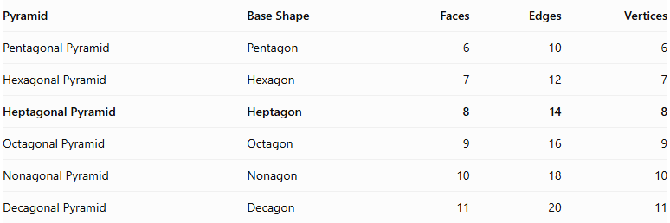
Pyramid | Base Shape | Faces | Edges | Vertices
Pentagonal Pyramid | Pentagon | 6 | 10 | 6
Hexagonal Pyramid | Hexagon | 7 | 12 | 7
Heptagonal Pyramid | Heptagon | 8 | 14 | 8
Octagonal Pyramid | Octagon | 9 | 16 | 9
Nonagonal Pyramid | Nonagon | 10 | 18 | 10
Decagonal Pyramid | Decagon | 11 | 20 | 11

Constructing Heptagonal Pyramid in Solid Geometry

Instruments Used
# Source: AI Source: Provided by: [Data Path: Persons Table -> ID Column: 1, Name_En Column: Motasem Essam] -> From: [ChatGPT] on [7/25/2026]
The construction uses physical geometric drawing instruments rather than coordinate-based methods.
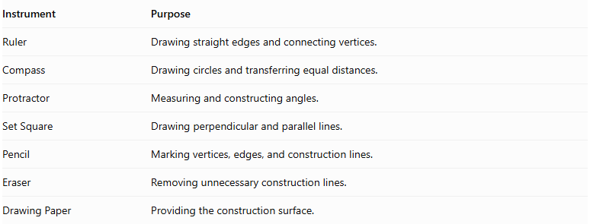
Instrument | Purpose
Ruler | Drawing straight edges and connecting vertices.
Compass | Drawing circles and transferring equal distances.
Protractor | Measuring and constructing angles.
Set Square | Drawing perpendicular and parallel lines.
Pencil | Marking vertices, edges, and construction lines.
Eraser | Removing unnecessary construction lines.
Drawing Paper | Providing the construction surface.

Construction Procedures

Base-Based Construction
# Source: AI Source: Provided by: [Data Path: Persons Table -> ID Column: 1, Name_En Column: Motasem Essam] -> From: [ChatGPT] on [7/25/2026]
- Draw a heptagonal base using a ruler, compass, and protractor.
- Identify and mark its seven vertices.
- Determine the position of the apex above or away from the base.
- Connect the apex to each of the seven base vertices.
- Complete the seven triangular lateral faces.
- Darken the visible edges and use dashed lines for hidden edges.

Apex-Based Construction
# Source: AI Source: Provided by: [Data Path: Persons Table -> ID Column: 1, Name_En Column: Motasem Essam] -> From: [ChatGPT] on [7/25/2026]
- Mark the intended apex position.
- Draw the heptagonal base beneath the apex.
- Identify the seven base vertices.
- Connect each base vertex to the apex.
- Complete the lateral triangular faces.

Vertex-Connection Construction
# Source: AI Source: Provided by: [Data Path: Persons Table -> ID Column: 1, Name_En Column: Motasem Essam] -> From: [ChatGPT] on [7/25/2026]
- Construct the seven vertices of the heptagonal base.
- Mark the apex as the eighth vertex.
- Connect the apex to all seven base vertices.
- Connect consecutive base vertices to complete the heptagonal base.
- Check that all edges and faces form a closed solid.

Edge-Based Construction
# Source: AI Source: Provided by: [Data Path: Persons Table -> ID Column: 1, Name_En Column: Motasem Essam] -> From: [ChatGPT] on [7/25/2026]
- Draw the seven edges of the heptagonal base.
- Determine the seven lateral edges extending from the base vertices to the apex.
- Construct and connect the lateral edges.
- Complete the triangular lateral faces.

Face-Based Construction
# Source: AI Source: Provided by: [Data Path: Persons Table -> ID Column: 1, Name_En Column: Motasem Essam] -> From: [ChatGPT] on [7/25/2026]
- Construct the heptagonal base.
- Draw seven triangular faces around the base.
- Connect the corresponding vertices and edges.
- Ensure that all seven triangular faces meet at the apex.

Net-Based Construction
# Source: AI Source: Provided by: [Data Path: Persons Table -> ID Column: 1, Name_En Column: Motasem Essam] -> From: [ChatGPT] on [7/25/2026]
- Draw one heptagonal base.
- Construct seven triangular faces around the heptagon.
- Add tabs if necessary for physical assembly.
- Cut out the net.
- Fold the triangular faces upward.
- Join their edges to form the heptagonal pyramid.

Applications
# Source: AI Source: Provided by: [Data Path: Persons Table -> ID Column: 1, Name_En Column: Motasem Essam] -> From: [ChatGPT] on [7/25/2026]
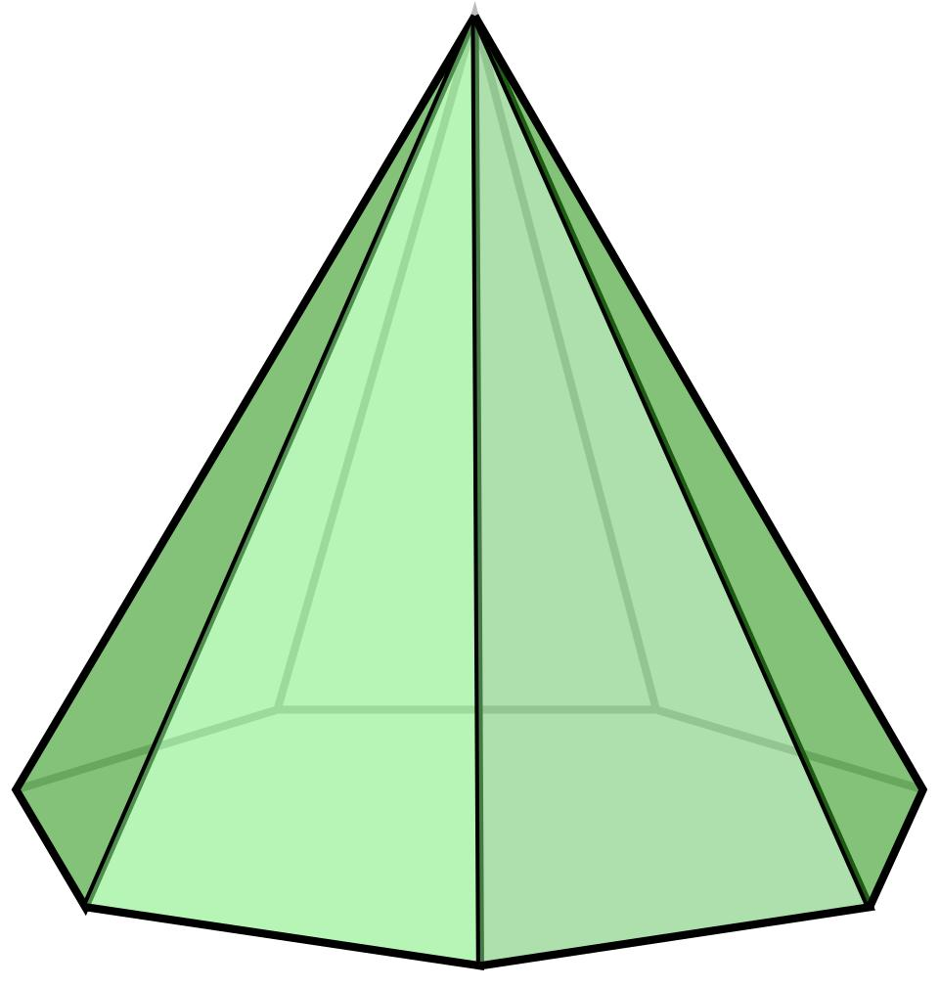
- Architecture: Geometric roof structures and decorative architectural designs.
- Mathematical Models: Teaching polygonal bases and three-dimensional geometry.
- Sculpture: Geometric decorative objects and artistic structures.
- Engineering: Studying triangular face arrangements and pyramid structures.

Key Points
# Source: AI Source: Provided by: [Data Path: Persons Table -> ID Column: 1, Name_En Column: Motasem Essam] -> From: [ChatGPT] on [7/25/2026]
- A Heptagonal Pyramid has one heptagonal base.
- It has seven triangular lateral faces.
- All seven lateral faces meet at one apex.
- It has 8 faces, 14 edges, and 8 vertices.
- Its volume is one-third of the product of its base area and perpendicular height.
- A regular right Heptagonal Pyramid has a regular heptagonal base and congruent isosceles triangular lateral faces.

Conclusion
# Source: AI Source: Provided by: [Data Path: Persons Table -> ID Column: 1, Name_En Column: Motasem Essam] -> From: [ChatGPT] on [7/25/2026]
A Heptagonal Pyramid is a polyhedron characterized by a seven-sided polygonal base and seven triangular lateral faces meeting at a single apex. It has 8 faces, 14 edges, and 8 vertices, making it an important member of the polygonal pyramid family.

